**MCC Math 132 Business Math Exam #1 February 26, 2024**

PLEASE READ: This exam is intended to be completed in one hour (60 minutes) but you will be allowed the full class time. This means all students are given extra time, regardless of whether you are on accommodations or not. ***Pay attention to point value on questions***!

**1. (52 pts)**

Name 3 resources and study tools that are available in Canvas, YouTube, or at MCC that you have been or will be using to help your study of this math class.

**2. (3 pts)**

I (your name)  will honor the code of conduct for exams at MCC and affirm that all answers are my own.

By entering your initials in the box below you are agreeing to the following conditions:

i.  You will not receive any help from other students or other individuals on these exam questions.

ii.  That you have made use of technology in an appropriate way without going to the internet for answers to questions.

Initial  here ==>  _____________

**3. (3 pts)**

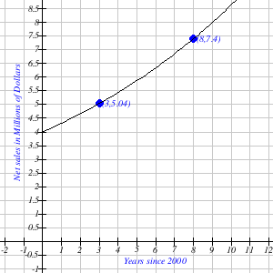The net sales of a company are shown in the graph. Estimate the average rate of change for 2003 to 2008. Round your answer to two decimal places. Interpret its meaning. The two points labeled are (8, 7.4) and (3, 5.04)  
  
Average rate of change = ______________

Interpret its meaning by ***selecting one*** of the following:  
Average rate of change is best described by:  

A. Sales decreased between 2003 and 2008

or

B. Sales increased between 2003 and 2008

**4. (3 pts)**

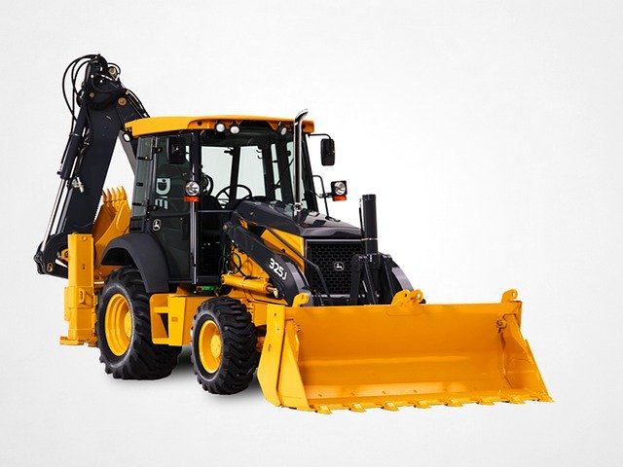Depreciation is the decrease or loss in value of an item due to age, wear, or market conditions.  
  
One company buys a new backhoe for $\$53500$. The company depreciates the backhoe linearly over its useful life of $15$ years. Its salvage value at the end of $15$ years is $\$14500$.  
  
**a)**  Construct a linear equation in the slope-intercept form that models the value, $V$, of the backhoe as a function of its age $x$ in years.

$V=$

_________________

**b)**  Use your model to find the value of the backhoe after $7$ years.

$V(7)=$ $\$$

____________

**5. (3 pts)**

A regression was run to determine if there is a relationship between hours of TV watched per day (*x*) and the number of sit-ups a person can do (*y*).  The results were:

y = b+mx  
m = $-0.79$  
b = 23.37  
r2 = 0.4647  
r = -0.6817

1. If a person watches 8 hours of television a day, predict how many sit-ups he can do.
2. If a person can do 5 sit ups, predict how many hours of television a day they watch.  
     
    _________ hours

**You may use a graphing tool of your choice to answer questions 6d and 7**

**6. (3 pts)**

You decide to begin selling frozen bananas at the local carnival. Your cost for each frozen banana is $1.95 plus you have to pay a fixed weekly fee of $250 for the booth. Your plan is to sell each frozen banana for $5.17.

1. Write a function, $C\left(x\right)$ , to represent your total costs for the week if you sell $x$ frozen bananas. $C\left(x\right)=$
2. Write a function, $R\left(x\right)$ , to represent the revenue from the sale of $x$ frozen bananas during the week. $R\left(x\right)=$
3. Write a function, $P\left(x\right)$ , that represents the profits for selling $x$ frozen bananas in a given week. $P\left(x\right)=$
4. How many items must you sell to break even?  
    _____________ frozen bananas

**7. (3 pts)**

At a price of $40 there is demand for 573 items and a supply of 320 items.  At a price of $80 there is demand for 453 items and a supply of 640 items.  Assuming supply and demand are linear, find the equilibrium price and quantity.

Equilibrium quantity: ____________   items

Equilibrium price:  $ ______________

**8. (3 pts)**

Given the table for $f$& $g$ below, find the following:

|  |  |  |
| --- | --- | --- |
| 0 | 0 | 0 |
| 1 | 7 | 6 |
| 2 | 2 | 8 |
| 3 | 9 | 2 |
| 4 | 6 | 3 |
| 5 | 3 | 7 |
| 6 | 4 | 9 |
| 7 | 5 | 1 |
| 8 | 8 | 4 |
| 9 | 1 | 5 |

Average rate of change of $g$ from x = $1$ to x = $5$

 

**9. (3 pts)**

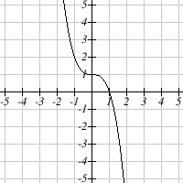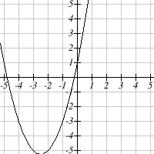Select the graph that represents a **linear function**. Circle the letter of the correct choice.

A. B.

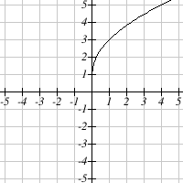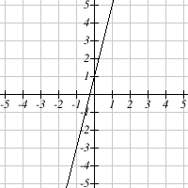

C. D.

**10. (3 pts)**

Find the equation of the line passing through the points (20,-23) and (-10,10). Write your answer in the form $y=mx+b.$ $y=$ 
  
  _________________

**11. (3 pts)**

Given the points $\left(-5,-4\right)$ and $\left(0,-1\right)$ on a line, find the values of m and b. $m=$ $b=$
  
 _______________  
  
 _____________  
  
Enter your answers as integers and/or as fractions in the form $\frac{A}{B}$ or as decimals rounded to the nearest hundredth.

**12. (3 pts)**

|  |
| --- |
| The relationship between two variables is given in the equation $28+16x=C$ . |

Which of the following situations could be represented using the equation above?

1. The fee for a computer consultant is $16 for an administration charge and $28 for each hour worked.
2. The cost of silk screening a design on T-shirts is $16 for each shirt created and a $28 design fee.
3. The price of a caterer for a party is $28 for each dinner ordered and $16 for each dessert ordered.
4. The bill for framing a painting is $28 for each square metre of glass required and $16 for the wooden frame.

**13. (3 pts)**

Which of the following is a graph of $y=2x-2$? Circle the letter of the correct choice.

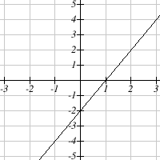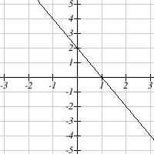

A.  
 B.

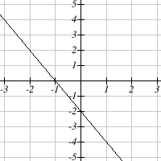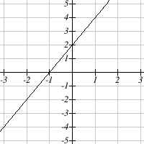

C. D.

**14. (3 pts)**

Given the function $f\left(x\right)=8x^{2}-6x+6$, determine $f\left(-4\right)$.



$f\left(-4\right)=158$

$f\left(-4\right)=-98$

$f\left(-4\right)=124$

$f\left(-4\right)=1054$

$f\left(-4\right)=-994$

**15. (3 pts)**

Determine the vertex of the quadratic function $y=x^{2}-6x+19$:

1. (6,19)
2. (6,10)
3. (3,10)
4. (3,38)
5. (3,19)

**16. (3 pts)**

A company's profit when it sells *x* thousand items is predicted to be $P\left(x\right)=-3x^{2}+1392x-20000$.  
  
a) What is the company's startup costs?  
  
$  _______________  
  
b) How many items does the company need to sell to break even? (to the nearest thousand items)  
  
  _______________ thousand items  
  
c) How many items should the company sell to maximize profit? (to the nearest thousand items)  
  
 ________________ thousand items

**17. (3 pts)**

Suppose that a company's profit (in terms of $x$, the number of units sold) is given by the model $P=-2x^{2}+168x-540.$ Find the profit when 38 units are sold.  
  
Answer: $P$ = _________  dollars.

***Some formulas you might need:***

average rate of change between two points (x,y) : $\frac{difference of y}{difference of x}=\frac{Δy}{Δx} or ∆y÷∆x$

slope of a line (given two points) is $m=\frac{Δy}{Δx}$;

y-intercept of a line $b=y-m⋅x$ (use any $(x,y)$ point to calculate it)

equation of a line (in slope-intercept form) is $y=mx+b$

quadratic functions can be written as $f\left(x\right)=ax^{2}+bx+c$

vertex of a quadratic is the point $(h, k)$ where $h=\frac{-b}{2a}$ and $k=ah^{2}+bh+c$